PROJECT REPORT

Superstore Management Project

# 

Name: Shruti Raju Bhujbal

Project Title: SuperStore Management Report

Language: Power BI

Date : 29-10-2024

Project Description:

This Power BI project aims to analyze sales data from the Superstore dataset to gain insights into orders, customers, profitability, and returns. Sales by product category and subcategory. Sales by region and state. Focus on high-profit products and reduce the inventory of low-profit or high return products.

Objectives:

1. Data Collection & Preparation:

• To gain a comprehensive understanding of the sales data and identify key trends and patterns.

• To analyze customer behaviour and preferences to optimize sales strategies

• Identify and remove inconsistencies, errors, and outliers.

• Handle missing values appropriately (e.g., imputation, deletion).

2]Data Transformation**:**

• Convert data into a suitable format for Power BI (e.g., tabular).

• Create calculated columns and measures to derive new insights.

• Aggregate data to appropriate levels for visualization.

3] Data Modeling:

• Design a data model that accurately represents the relationships between tables and fields.

• Optimize the data model for performance and query efficiency.

4] Visualization & Reporting:

• Create visually appealing and engaging visualizations that convey insights effectively.

• Utilize a variety of chart types (e.g., bar charts, line charts, pie charts, maps) to suit different data types and analysis needs.

5] Snapshots:

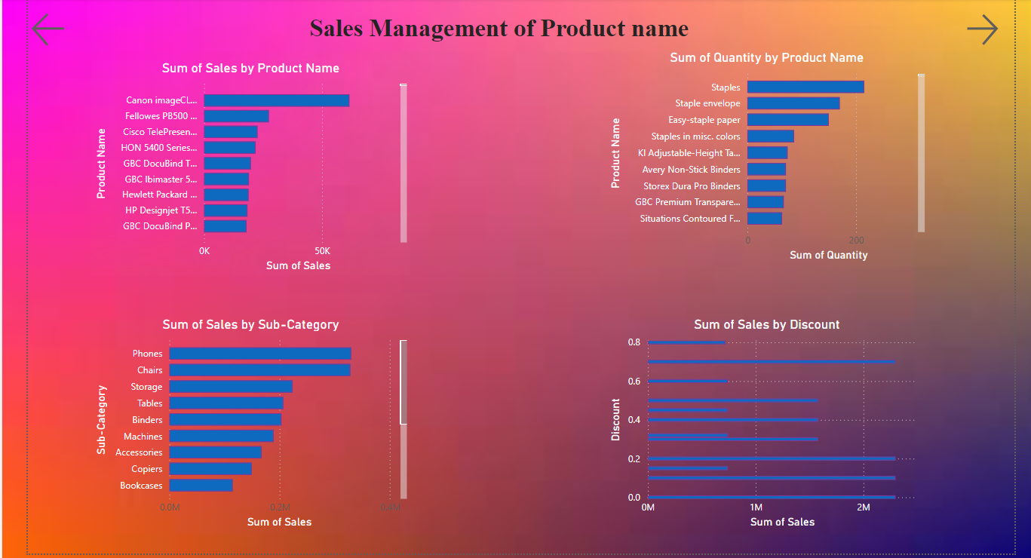

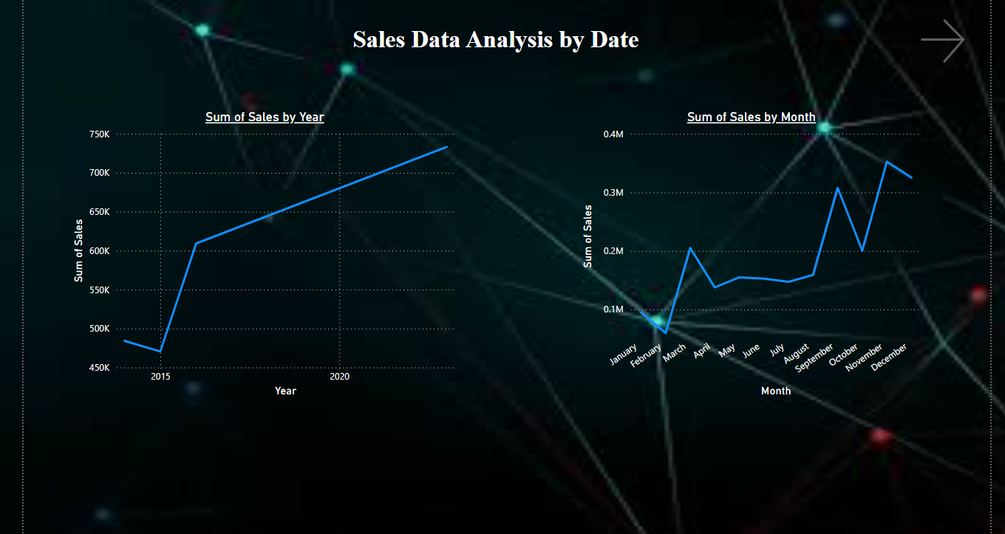

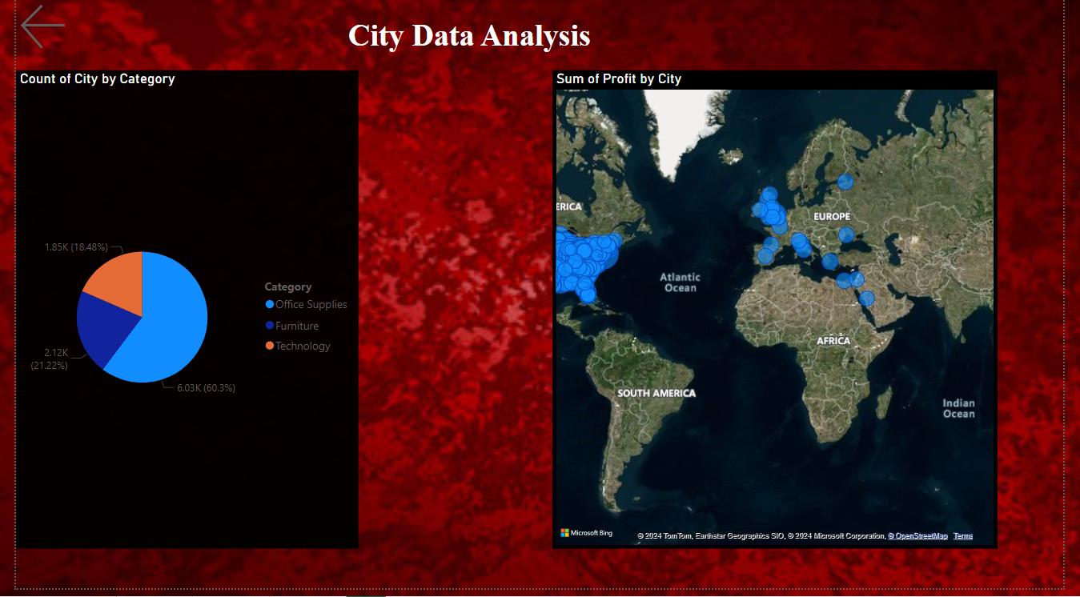

➔ Conclusion:

• By leveraging Power BI's powerful data visualization and analysis capabilities,

• we have gained valuable insights into the Sample Superstore's operations.

• The findings from this project can be used to make data-driven decisions to improve sales, profitability, and customer satisfaction